**CA#6 Part 2**

**Natural Language Understanding**

**Abstraction**

**Intent detection** and **slot filling** are the main tasks to solve when approaching the  
problem of **Natural Language Understanding (NLU)** in a **conversational system**. The two tasks are used to obtain a structured representation of the meaning of the utterance, so that it can be processed by a computer. Intent detection deals with identifying the **overall meaning** of the sentence. It is modeled as a **classification** problem, in which we receive an input utterance and we have to classify it as having one intent from a group of known intents. The available intents correspond to the actions that the conversational model can perform, such as adjusting the temperature, controlling the media center or turning the lights on/off in the case of a home assistant. On the other hand, slot filling is modeled as a **sequence labelling problem**, whose purpose is to take the utterance and determine which words **indicate relevant information for the intent**. These slots contain supplementary information about the action and correspond to the parameters of the action.

The task-oriented dialogue system is the basis of virtual assistants like Alexa, Siri, Cortana, and Portal has been increasingly used in modern society; users interact with them across different domains to complete diverse tasks and achieve their specific goals. Key component of these task-oriented dialogue systems is Natural Language Understanding (NLU) which aims to derive the intent of users and fill the value for the slots of the utterance.

**Dataset**

**MASSIVE** is a parallel dataset of > 1M utterances across **51 languages** with annotations for the Natural Language Understanding tasks of intent prediction and slot annotation. Utterances span **60 intents** and include **55 slot** types. MASSIVE was created by localizing the [SLURP](https://github.com/pswietojanski/slurp) dataset, composed of general Intelligent Voice Assistant single-shot interactions.

In this assignment, we are to use Farsi Dataset (fa-IR.jsonl). This Json file contains train, dev and test sets. Now will study the details of this dataset:

Figure 1 Input Jsonl file format details

In this assignment the “judgments” and “worker_id” are not considered.

There are 60 different intents and 56 different slots in this dataset.

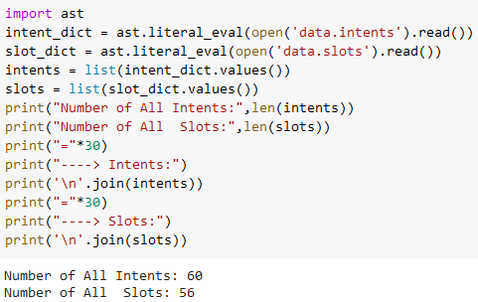

Figure 2 Number of slots and intents

Now we take a look at intents list:

----> Intents:

recommendation_locations

play_music

iot_cleaning

email_addcontact

datetime_convert

transport_ticket

qa_stock

lists_query

email_query

datetime_query

calendar_remove

iot_wemo_off

recommendation_events

email_sendemail

qa_maths

general_quirky

calendar_query

iot_hue_lighton

audio_volume_other

takeaway_order

transport_query

weather_query

alarm_set

qa_factoid

play_radio

lists_remove

qa_currency

news_query

lists_createoradd

general_greet

social_query

iot_hue_lightchange

iot_hue_lightdim

calendar_set

iot_hue_lightup

recommendation_movies

play_audiobook

alarm_query

audio_volume_up

cooking_recipe

iot_wemo_on

social_post

qa_definition

audio_volume_mute

general_joke

iot_hue_lightoff

music_dislikeness

transport_traffic

takeaway_query

play_podcasts

iot_coffee

audio_volume_down

play_game

transport_taxi

email_querycontact

music_query

cooking_query

music_likeness

music_settings

alarm_remove

Now we take a look at slots list:

----> Slots:

transport_agency

playlist_name

house_place

media_type

time_zone

time

device_type

business_name

music_album

artist_name

podcast_descriptor

personal_info

email_folder

news_topic

order_type

podcast_name

food_type

transport_type

game_type

general_frequency

list_name

app_name

audiobook_name

sport_type

alarm_type

song_name

place_name

game_name

music_genre

person

change_amount

date

ingredient

radio_name

email_address

meal_type

movie_name

definition_word

transport_name

coffee_type

relation

event_name

currency_name

business_type

music_descriptor

weather_descriptor

timeofday

movie_type

transport_descriptor

joke_type

Other

color_type

player_setting

audiobook_author

cooking_type

drink_type

Here we can compare frequencies of **domains**, **intents** and **slots** count in each partision:

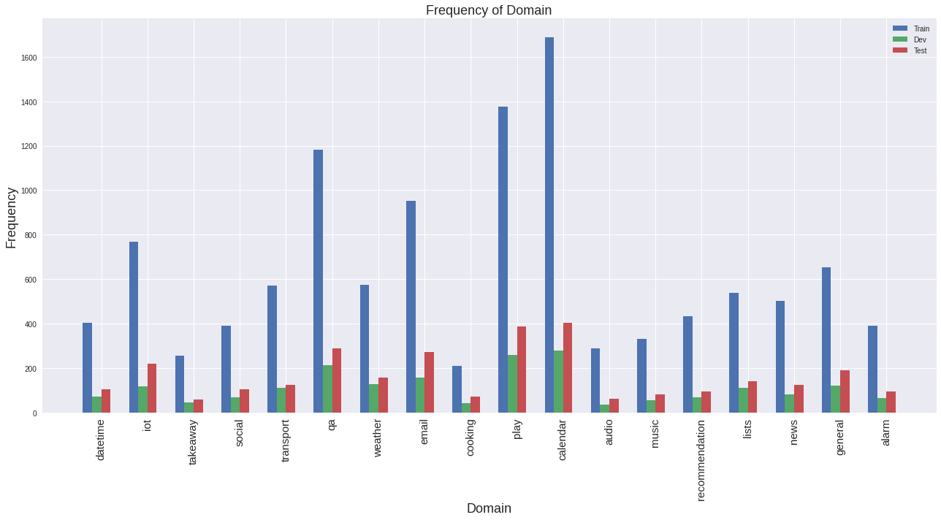

Figure 3 Domain Frequency Bar Plot

As we can see above, the **calendar** domain is the most frequent domain.

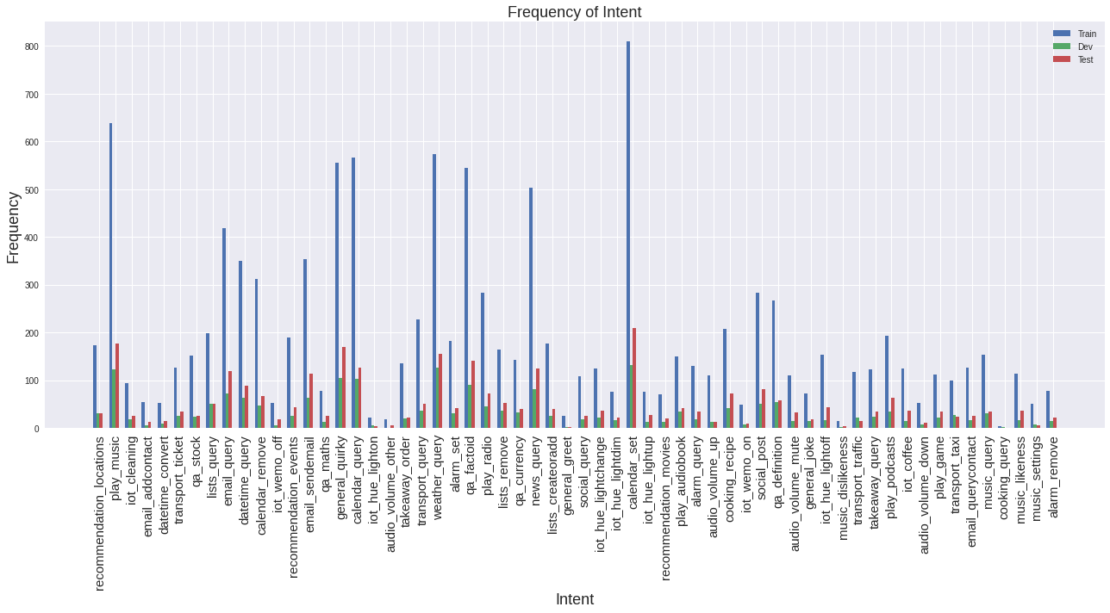

Figure 4 Intent Frequency Bar Plot

As we can see above, the **calendar_set** intent is the most frequent and cooking_query is the least frequent intent.

Figure 5 Slot Frequency Bar Plot

As we can see above, the **date** slot is the most frequent slot.

Here are some more details of counts:

|  |  |  |
| --- | --- | --- |
| Figure 6 Domain frequencies | Figure 7 Intent frequencies | Figure 8 slot frequencies |

**Preparing Dataset**

I put the fa-IR-jsonl file in “Dataset” folder and passed it to create_hf_dataset.py.

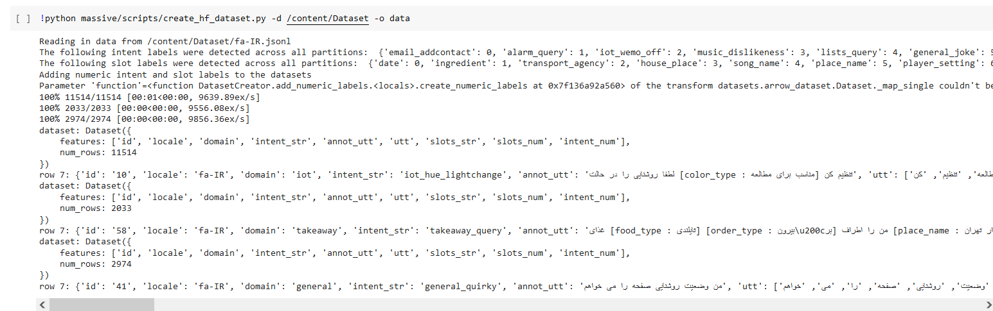

Figure 9 Creating Dataset

The create_hf_dataset.py python file has a class which prepare the dataset and parse Jason file. This class if for creating four dataset splits, in the Huggingface Datasets Apache Arrow format from the MASSIVE dataset.

Each dataset split has the following **columns**:

"id", "locale", "utt", "annot_utt", "domain", "intent_str", "intent_num", "slots_str", "slots_num"

**Methods:**

* create_datasets(data_path): Creates the dataset splits using the data_path of the MASSIVE set
* add_numeric_labels(): Create integer versions of intents and slot for modeling
* investigate_datasets(): Prints out the seventh example from each dataset split as gut check
* save_label_dicts(prefix): Saves the mappings to the integer versions of the labels
* save_datasets(out_prefix): Saves the datasets to out_prefix

In this implementation each intent and slot is mapped to a number in order to make it possible to process and use them in training.

**Training**

I cloned the MASSIVE github to get the needed python files.

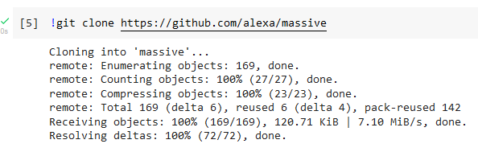

Figure 10 Cloning Massive

Here I used the xlm-roberta-base model for training. For training we use the following script and pass a config file to set the parameters of the model. This file is included in the folder uploaded named “train_config.yml”. Overally, in train.py the following procedure flows:

* parsing the args
* creating the massive.configuration master config object
* Seting up logging
* Getting all inputs to the trainer
* Getting the right trainer

As I mentioned before, we need to pass a configuration file. We need to especify **pretrained_weights** and **vocab_file** in this file. For these to fields I used pytorch_model.bin and sentencepiece.bpe.model in xlm-roberta-base of huggingface:

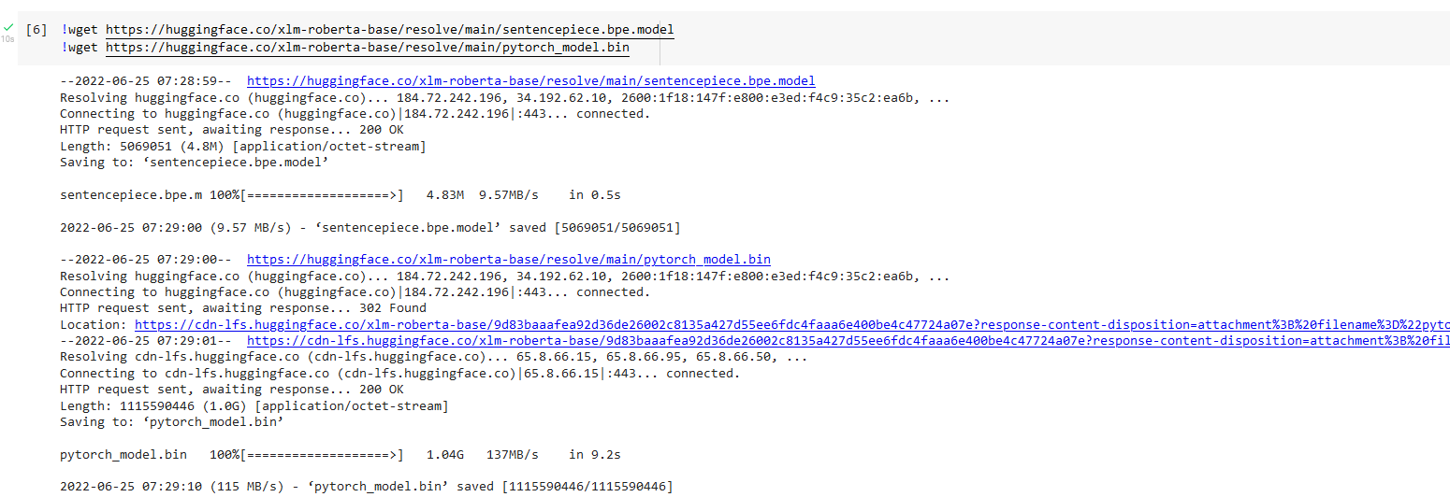

Figure 11 Getting xlm-roberta-base files

I trained the model with batch_size of 128 and 45 epochs. Configuration file can be fully observed in the uploaded file but I will explain some of the parameters here.

The model and tokenizer parameters are:

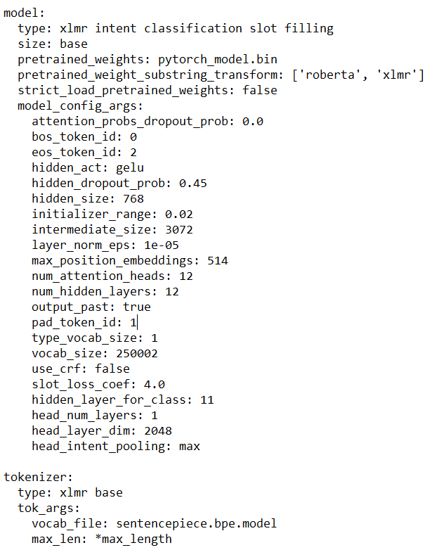

Figure 12 Parameters

As we can see we use the pytorch_model.bin for pretrained_weights and sentencepiece.bpe.model for vocab_file in xlm-roberta-base. The head layer dimension is 2048 and and number of hidden layers are 12. By setting these parameters we get the following architecture:

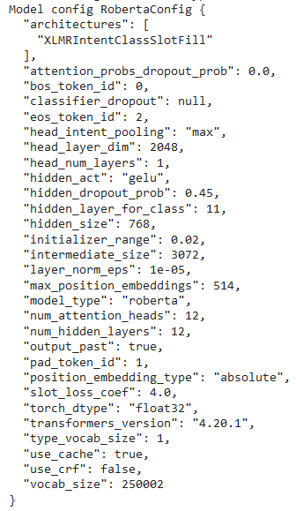

Figure 13 Model architecture details

Train and validation parameters are:

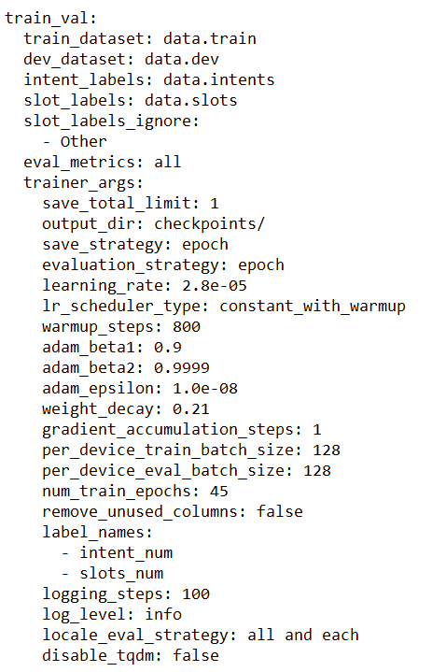

Figure 14 Parameters

As we can see the batch size is 128, learning rate is initially set to 0.000028. we used the adam optimizer and the epochs are 45. Pay attention since in this implementation there is a “other” slot which corresponds to no slots defined we ignore it.

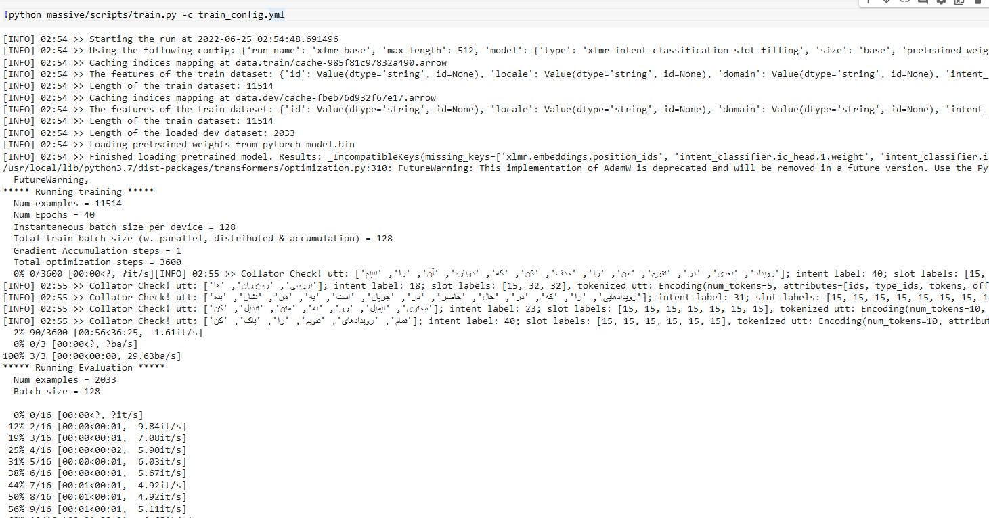

Figure 15 Training

After training by 45 epoches this is the **results**:

{'training_global_step': 3600, **'training_epoch': 45.0**, 'eval_fa-IR_loss': 1.8478409051895142, **'eval_fa-IR_intent_acc': 0.8494835218888342,** 'eval_fa-IR_intent_acc_stderr': 0.007930504466678288, **'eval_fa-IR_slot_micro_f1': 0.7392102846648301,** 'eval_fa-IR_slot_micro_f1_stderr': 0.0015396802730499027, 'eval_fa-IR_ex_match_acc': 0.6148548942449582, 'eval_fa-IR_ex_match_acc_stderr': 0.010792692898620112, 'eval_fa-IR_runtime': 3.6738, 'eval_fa-IR_samples_per_second': 553.373, 'eval_fa-IR_steps_per_second': 4.355, **'eval_all_loss': 1.8478409051895142**, **'eval_all_intent_acc': 0.8494835218888342**, 'eval_all_intent_acc_stderr': 0.007930504466678288, **'eval_all_slot_micro_f1': 0.7392102846648301**, 'eval_all_slot_micro_f1_stderr': 0.0015396802730499027, **'eval_all_ex_match_acc': 0.6148548942449582**, 'eval_all_ex_match_acc_stderr': 0.010792692898620112, 'eval_all_runtime': 3.669, 'eval_all_samples_per_second': 554.109, 'eval_all_steps_per_second': 4.361, 'eval_highest-locale_intent_acc': 'fa-IR', 'eval_highest-locale-val_intent_acc': 0.8494835218888342, 'eval_lowest-locale_intent_acc': 'fa-IR', 'eval_lowest-locale-val_intent_acc': 0.8494835218888342, 'eval_highest-locale_slot_micro_f1': 'fa-IR', 'eval_highest-locale-val_slot_micro_f1': 0.7392102846648301, 'eval_lowest-locale_slot_micro_f1': 'fa-IR', 'eval_lowest-locale-val_slot_micro_f1': 0.7392102846648301, 'eval_highest-locale_ex_match_acc': 'fa-IR', 'eval_highest-locale-val_ex_match_acc': 0.6148548942449582, 'eval_lowest-locale_ex_match_acc': 'fa-IR', 'eval_lowest-locale-val_ex_match_acc': 0.6148548942449582, 'epoch': 45.0}

**Testing**

For testing we use the following script and pass a config file to set the parameters of the model. This file is included in the folder uploaded named “test_config.yml”. These parameters are as follows:

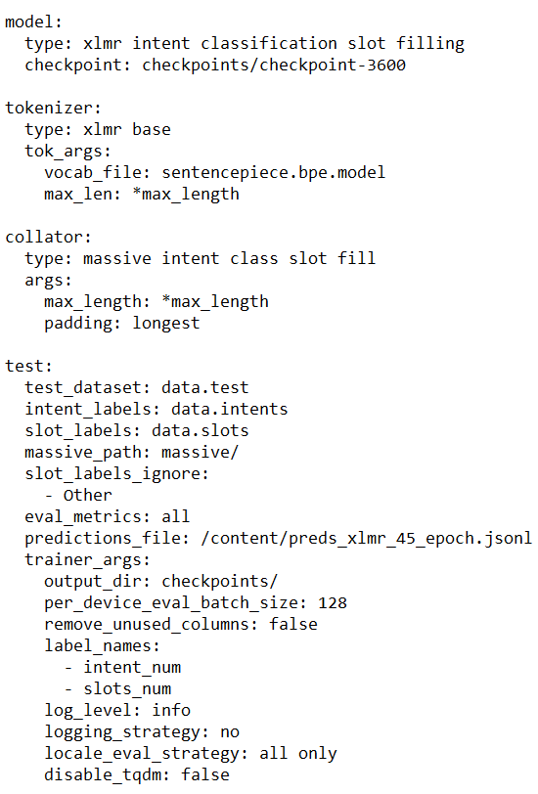

The batch size is 128 and I save the predictions in preds_xlmr_45_epoch.jsonl file.

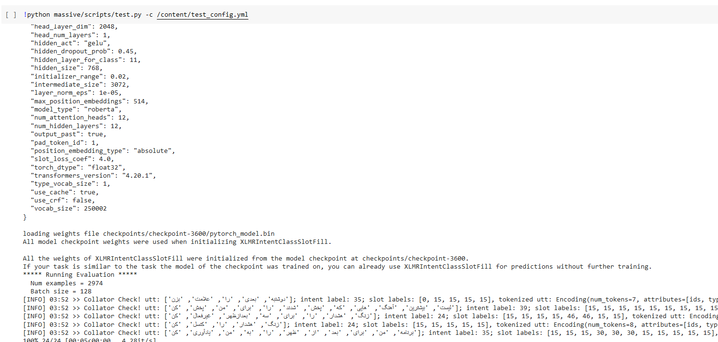

Figure 16 Testing

**Results** of testing are:

{ **'test_all_ex_match_acc': 0.6146603900470746,**

'test_all_ex_match_acc_stderr': 0.008924193086447684,

**'test_all_intent_acc': 0.8490248823133827,**

'test_all_intent_acc_stderr': 0.006565116171480395,

'test_all_loss': 1.9511113166809082,

'test_all_runtime': 6.1897,

'test_all_samples_per_second': 480.475,

**'test_all_slot_micro_f1': 0.7281713344316308,**

'test_all_slot_micro_f1_stderr': 0.0009614521731479325,

'test_all_steps_per_second': 3.877

}

As we can see the results of the model are very good and close to the accuracies mentioned in the [Massive paper.](https://arxiv.org/pdf/2204.08582.pdf)

The results reported in the paper are:

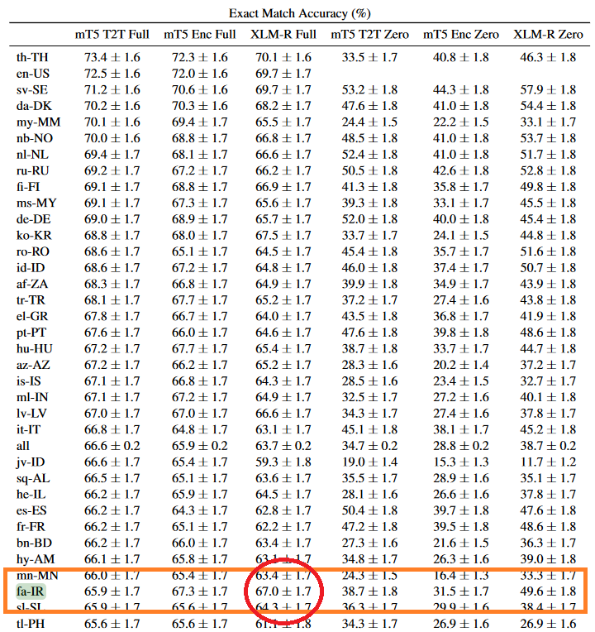

Figure 17 Exact Match Accuracy in the paper

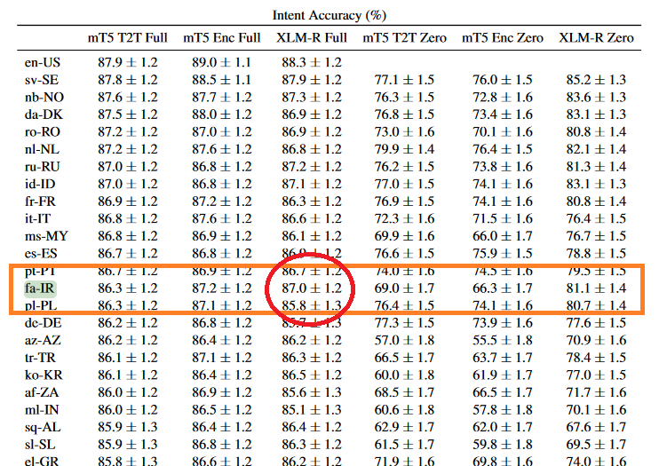

Figure 18 Intent Accuracy in the paper

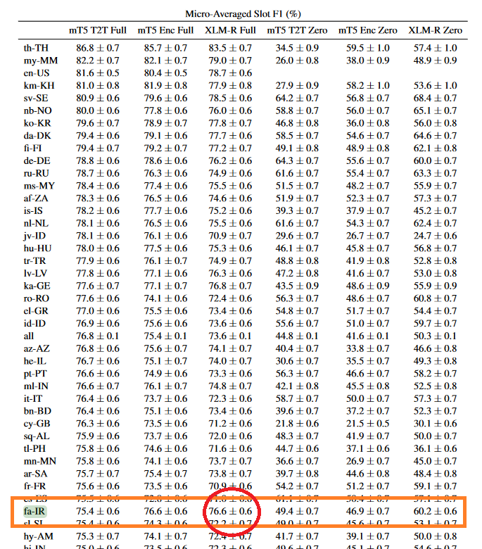

Figure 19 Micro-Averaged Slot F1 in the paper

Now, lets look at some prediction by more details:

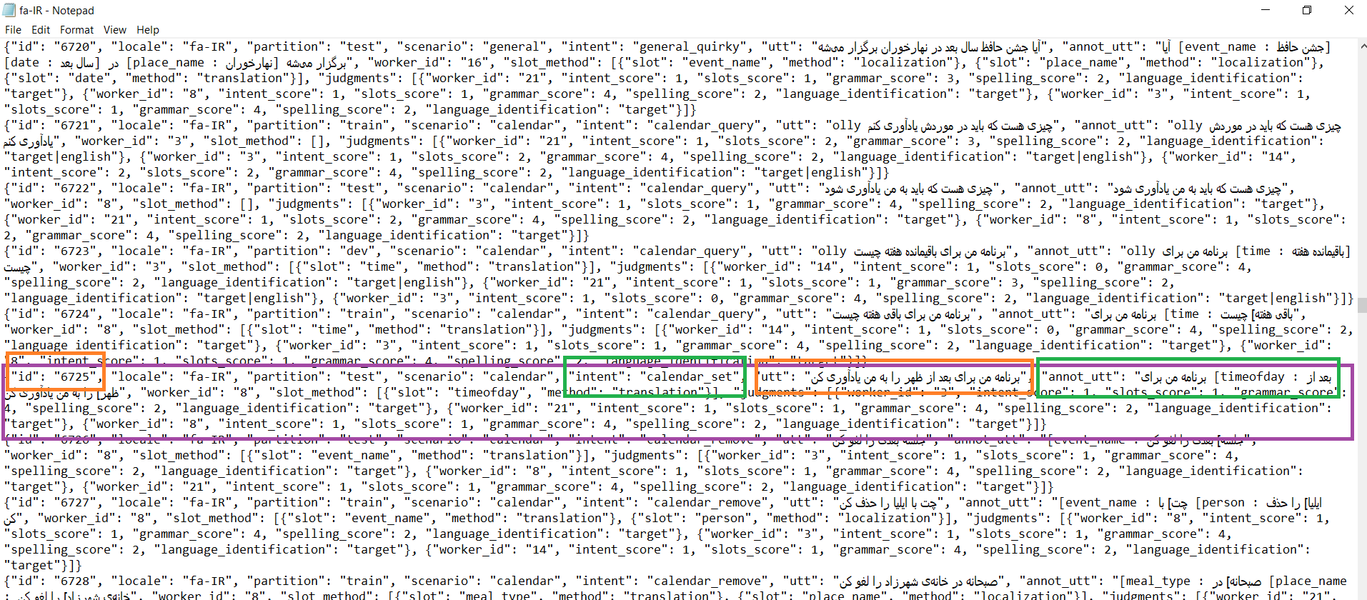

Figure 20 Id 6725 - Actual

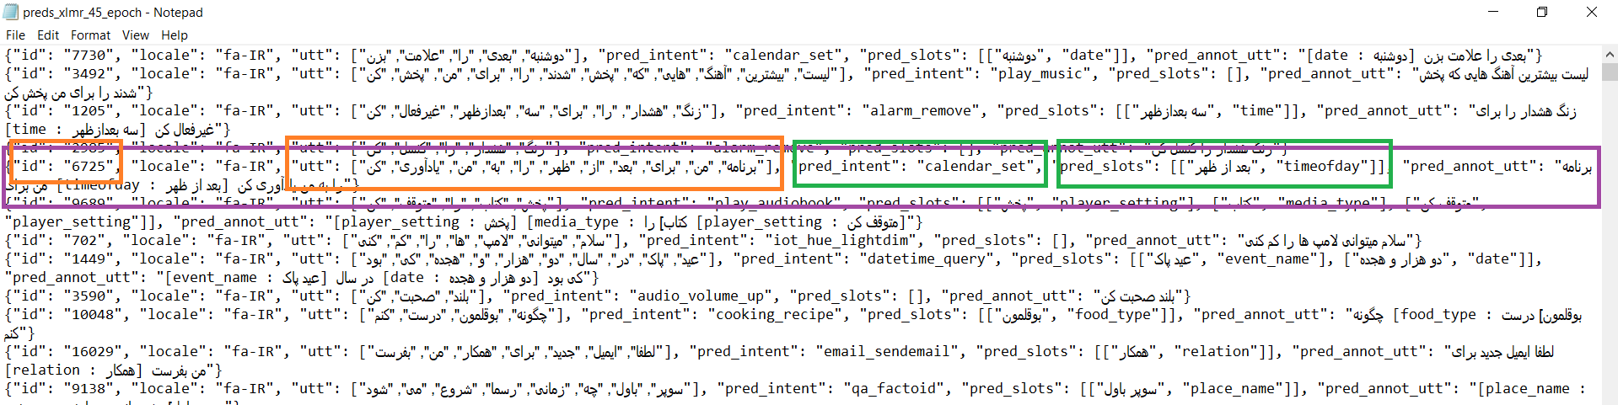

Figure 21 Id 6725 - Predicted

As we can see the prediction is correct an this confirms the results scores I showed above.

I also trained the model on mt5_enc_base. The results are:

'test_all_ex_match_acc': 0.594371217215870881,

'test_all_ex_match_acc_stderr': 0.0012097048826613399,

'test_all_intent_acc': 0.699394754539341,

'test_all_intent_acc_stderr': 0.008407927933758254,

'test_all_samples_per_second': 518.046,

'test_all_slot_micro_f1': 0.70055148853099072,

'test_all_steps_per_second': 8.187

}

Which we can see the results with xlm-roberta-base were better.

**Some problems I encountered during completing this part:**

Since creatigng the environment given in massive github was not easy I tried to run the codes without that environment. So I installed packages and dependencies manually and by a req.txt file wich is included in the folder uploaded. Without the given environment I got some errors during running the train.py and test.py so, I needded to change some parts of the code especially the importing parts. After trying to handle these errors I realized by using this command all the erros will be gone.



Another problem was the disk capacity of google colab which leaded to errors. In order to handle this I used an filed named save_total_limit = 1 in the training config file which will save just the last checkpoint not all the checkpoints.

*** for running the note book file make sure you have the “Dataset” folder which included the “fa-IR.jsonl” file, the req.txt file and train_config.yml and test_config.yml.

**References:**

https://arxiv.org/pdf/2204.08582.pdf

<https://arxiv.org/pdf/2010.11934.pdf>

<https://arxiv.org/abs/1911.02116>

<https://mdpi-res.com/d_attachment/sensors/sensors-21-01230/article_deploy/sensors-21-01230-v3.pdf?version=1614215625>